Technical Report

Magnetic Gadget Kit

Designed and Produced by Haixiang Xu[1] @ Meister Lab

Sep. 2016

## Overview

The project is intended to design and produce a set of lab experiment kit for magnetic perception research of neurons. It includes two major parts: the electromagnet and the magnetometer, and the design files, user manuals for both of them.

The electromagnet, also referred to as ‘Magneto’, is a 3.5mm audio jack powered, compact gadget to generate static or low frequency alternative electromagnetic fields, which is the most important part of generating magnetic field necessary for researches on magnetic field perception. And the magnetometer provides the additional, accurate measurement to properly monitor and record the field that is actually applied to the neurons.

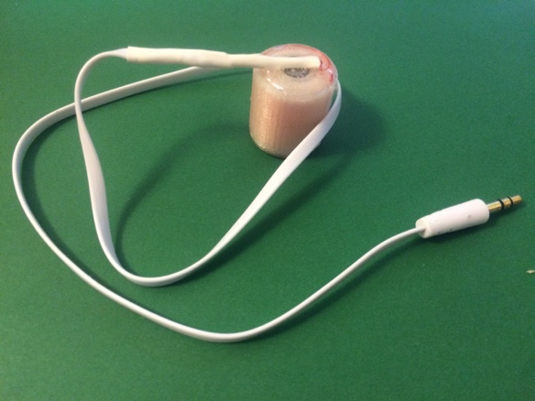 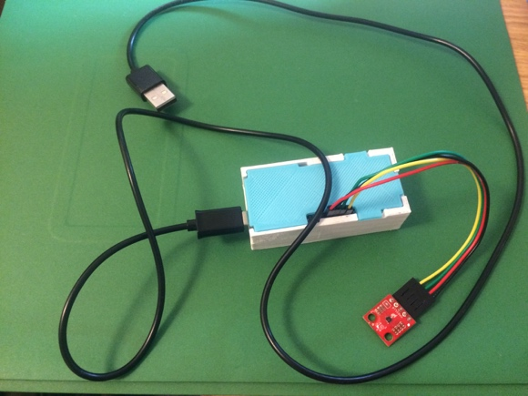

Figure 1. Magneto gadgets Figure 2. Magnetometer

There are 50 electromagnets and 1 magnetometer already made and ready to be implemented, the design files and production guidance is written up for future manufacturing. Please read through this report thoroughly before using these gadgets or making any modification of these products. The whole project files can be found on the following link:

Link

## Electromagnet

* Design and Production

The design of Magneto is straightforward. It is bobbin shaped, and consists of two coaxial plastic cylinders which act as inner tube and outer case. On each end of the cylinder there are epoxy seals that help fixing the bobbin.

The cylinders are produced with 3D printing, and designed with Autodesk Inventor. The models are tuned with Cura slicing software, and the model files can be found in the package. 3D printers in Caltech TechLab is free to use, and we recommend using Bukito or Mod-T to print these materials.

Fig 3. The three-view of Magneto

Fig 4. The three-view of the design drawing

In between the coaxial cylinders there is the magnetic coil. The coils are made from name of magnetic wires, and in each coil there are 1000 windings.

The ends of the coil are soldered to the break-outs of a 3.5mm audio cable. Note that only the left audio signal channel and the ground line are used, the right channel is open circuited. The junction is fixed and strengthened by head-shrinking tubes to ensure proper mechanical strength.

Fig 5. Break-out look inside and connection

* Properties

Physical Specs:

|  |  |  |
| --- | --- | --- |
| Inner cylinder | Inner diameter |  |
| Outer diameter |  |
| Outer cylinder | Inner diameter |  |
| Outer diameter |  |
| End wall thickness | |  |
| Outer height | |  |
| Working temperature | |  |
| Audio cable length | |  |

Electrical Properties:

|  |  |
| --- | --- |
| Resistance |  |
| Coil winding |  |
| Input voltage |  |
| Input current |  |
| Frequency |  |

* Usage

The usage of the gadget is extremely easy. The gadget is compatible with most smart phones, both in Android and iOS systems.

* + Plug the audio cable into 3.5mm audio jack
  + For alternative magnetic field, use signal generating Apps (recommended below)
    - Signal Generator: Audio Test Tone Utility

<https://itunes.apple.com/us/app/signal-generator-audio-test/id543661843?mt=8>

* + - Function Generator

<https://play.google.com/store/apps/details?id=com.keuwl.functiongenerator&hl=en>

* + For other special waveform or static magnetic field, please use proper app or use a professional function generator
  + Tune to proper volume, and the magnetic field is ready to be used
* Manufacturing steps

The manufacturing or production of the gadget depends on many software, the general rules follow design 🡪format🡪slice🡪print pattern. To make more gadgets in the future, please follow the following steps:

* + Download and install Autodesk Inventor[2], or Windows 10 pre-installed 3D Builder[3] software
  + Open design files (.) or modify them and save as .stl file
  + Open the .stl file with Cura[4], properly set Cura with specific printer parameters, and place the model in workspace
  + Modify in Cura, print in batches or place models closer, save the file with .gcode format or .g format
  + If use Mod-T, connect the machine with USB cable,
    - Open .gcode file with Mod-T printer utility[5]
    - Load .gcode files, press print to start printing
  + If use Bukito,
    - Change name of the .gcode file to auto0.g
    - Copy the file into micro SD card, insert into Bukito machine, press start to begin printing

For the detailed training of 3D printing process or design procedures, please follow the instructions in the link below, or ask for assistance from TechLab librarians.

* + How To: use Cura with Mod-T

<http://blog.newmatter.com/how-to-use-cura-with-the-mod-t/>

* + How To: use Cura with Mod-T

<http://bukobot.com/bukito>

## Magnetometer

* Design and Overview

The magnetometer is an Arduino based magnetic field sensor. We choose MAG3110 as magnetic sensor chip, and use Arduino Fio v3 as data board. The system is powered with USB cable and transmit data back to PC with USB-Serial port. Data transmission between data board and sensor is via I2C protocol. To make the magnetometer more compatible and easy to use, we designed a 3D printed case to protect the data board, connecting MAG3110 sensor with Dupont wires.

Fig 5. Magnetometer overview

All the sensor chips and Arduino board can be purchased from sparksfun website[6], and made easily with the software provided in the package. A Python script is used for PC or Mac to collect data from USB port, data will be stored in a plain text file, which can be imported with Matlab or other data analysis tools.

The magnetometer is equipped with auto-calibration features, the first 15s after powering up is used explicitly for calibration purpose. To properly calibrate the sensor, please put the sensor inside the Zero-field cylinder while the blue LED light is blinking. After the blue light stabilized, take out the sensor and it is ready to measure magnetic field. The magnetometer can be used for a wide range of magnetic fields. Data collection rate is set to 50 Hz, however, this rate can be further tuned according to the later using scenarios.

Moreover, the script is featured with a graph display of real-time magnetic field amplitude for more convenient magnetic field monitoring.

Fig 6. Graphical UI monitor

* Hardware List

|  |  |
| --- | --- |
| Ardiono Fio v3 | 1 |
| MAG3110 breakout chip | 1 |
| USB cable | 1 |
| Dupont wire (F-F) | 4 |
| 3D printed case | 1 |
| Zero-field calibration cylinder | 1 |

* Software List

|  |  |
| --- | --- |
|  |  |
|  |  |

* Specs and Features

|  |  |
| --- | --- |
| Power supply | 5V (USB) |
| Vcc | 3.3V (Fio v3) |
| Magnetic field range | 1000 mT |
| Number of measuring axis | 3 |
| Communication Protocol | I2C |
| Data collection rate | 50Hz |
| Accuracy | 0.1 mT[7] |
| Calibration period | First 15 s powering up |

* Usage
  + Keep the sensor in the Cylinder
  + Plug in USB cable to power up
  + Wait for the magnetometer to calibrate, blue LED will blink
  + During calibration, run python script with terminal call

CALL

* + After the LED lights up, take out the sensor and measure. Monitor the field amplitude from graphic UI
  + After the measurement, put the sensor back to the zero-field cylinder
  + Unplug the USB cable, or press Ctrl-C to end the Python script
  + Save result from result.txt and use for future analytics
* Production

The production of magnetometer is very simple. At the first time of use, pluging in the USB cable, and download .ino program from Arduino Software[8]. After the download is completed, Arduino board will run the program automatically.

Copy the python file in the same folder, and it can be used on any PC machine with Python environment installed.

1. Haixiang Xu: hxu@caltech.edu
2.
3.
4.
5.
6.
7.
8. <https://www.arduino.cc/en/Main/Software>